EE5907 CA1 Programming Assignment

Name: Zhu Qi

Matric Number: A0224460N

Contents

Q1. Beta-binomial Naïve Bayes 2

1 Plots of training and test error rates versus α. 2

2 What do you observe about the training and test errors as α change? 2

3 Training and testing error rates for α = 1, 10, and 100. 3

Q2. Gaussian Naïve Bayes 3

1 Training and testing error rates for the log-transformed data. 3

Q3. Logistic Regression 4

1 The plot of training and test error rates versus λ 4

2 What do you observe about the training and test errors as λ change? 4

3 Training and testing error rates for λ = 1, 10, and 100. 5

Q4. K-Nearest Neighbours 6

1 The plot of training and test error rates versus K 6

2 What do you observe about the training and test errors as K change? 6

3 Training and testing error rates for K = 1, 10, and 100. 7

Q5. Survey 7

1 Time Spent 7

2 Feedback 7

# Q1. Beta-binomial Naïve Bayes

## Plots of training and test error rates versus α.

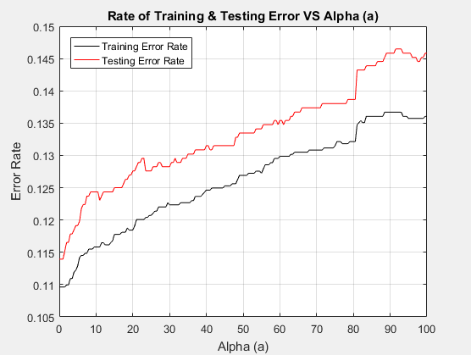

## What do you observe about the training and test errors as α change?

From the observation shown above, both the training and test error rates will *increase proportionally* to α at a similar trend.

Generally speaking, the testing error rate is higher than the training error rate. Both the training and test error rates fluctuate while increasing and *increased sharply at* the beginning from *α = 0 to α = 10*, as well as at *α= 80* ( the screenshots fo the coordinates are showing in the figures below). Therefore we can know if we have sufficient training, or whether we have chosen a suitable value of α t to reduce the error rate by observing these trends.

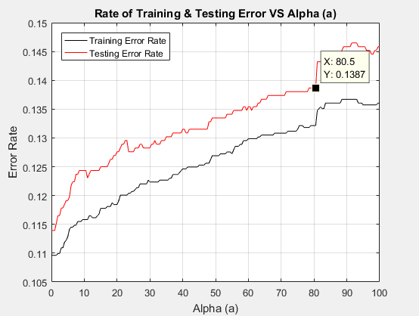 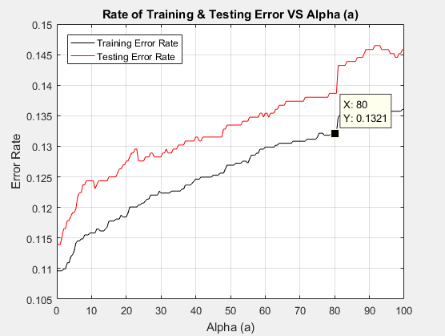

## Training and testing error rates for α = 1, 10, and 100.

|  |  |  |
| --- | --- | --- |
| **α** | **Training Error Rate** | **Testing Error Rate** |
| 1 | 0.109625 | 0.113932 |
| 10 | 0.115824 | 0.124349 |
| 100 | 0.136052 | 0.145833 |

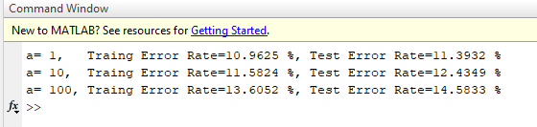

# Q2. Gaussian Naïve Bayes

## Training and testing error rates for the log-transformed data.

|  |  |  |
| --- | --- | --- |
|  | **Training Error Rate** | **Testing Error Rate** |
| **Log Transformed Data** | 0.166721 | 0.183594 |

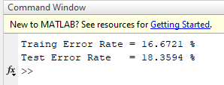

From the observation of the error rate for the log-transformed data using the Gaussian Naïve Bayes classifier (training error rate = 16.67% and testing error rate = 18.36%) is higher than the result error rates from the beta-binomial Naïve Bayes classifier in the worst scenario (when α=100, training error rate = 13.60% and testing error rate = 14.58% ).

Therefore, by comparing questions one and two, we know that Beta-Binomial Naïve Bayes Classifier is better for this case.

# Q3. Logistic Regression

## The plot of training and test error rates versus λ

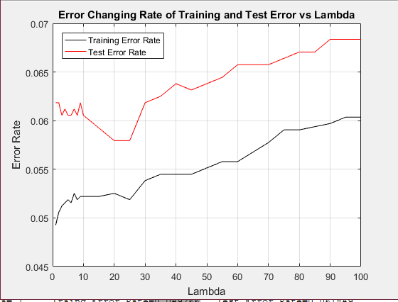

## What do you observe about the training and test errors as λ change?

From the observation of the plot above, generally speaking, the error rate of test data is higher than the training data and both of them are remaining less than 7.00%.

While **λ** is increasing, the difference between Training and testing error rate forms 2 trends:

1. When 0 ≤ λ ≤20 (coordinate is indicated in the plot below), the difference between training and the test error rate is gradually decreasing, the training error rate is increased proportionally to λ with fluctuation, while the testing error rate has a huge spike of fluctuation λ ≤10, and then decreased proportionally to λ.
2. When λ > 20, the difference between training and the test error rate is roughly remaining as a constant, and both training and test error rates are increasing proportionally with **λ** with some small fluctuations.

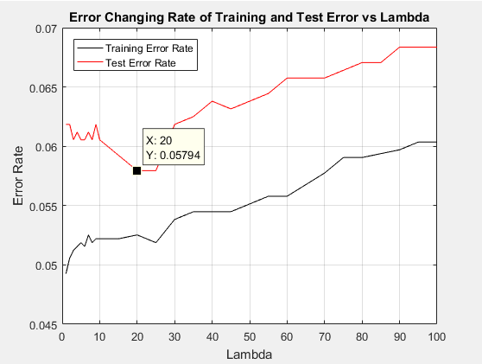

## Training and testing error rates for λ = 1, 10, and 100.

|  |  |  |
| --- | --- | --- |
| **λ** | **Training Error Rate** | **Testing Error Rate** |
| **1** | 0.049266 | 0.061849 |
| **10** | 0.052202 | 0.060547 |
| **100** | 0.060359 | 0.068359 |

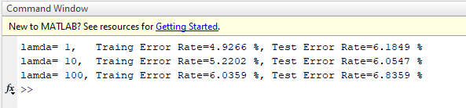

# Q4. K-Nearest Neighbours

## The plot of training and test error rates versus K

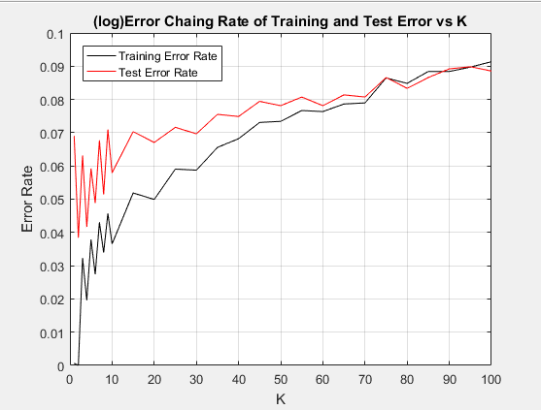

## What do you observe about the training and test errors as K change?

As K increased from 1 to 100, the relationship between error rates and K can be categorized into 2 parts:

1. When 0 ≤ K ≤ 75, Test Error Rate is always higher than the Training Error Rate, and they are gradually getting closer to each other while K increasing:

When 0 ≤ K ≤10, both Training & Test error rates increased with huge spikes and fluctuations.

* 1. At K=1, the Training Error Rate is very low (1, 0.0006525) but not equal to 0. Because some samples have the same features distance=0 but from different classes.
  2. When K >10, the waveform became smoother and the difference between the error rate of Training and Test error reduced gradually until they cross with each other at K =75.

1. When k > 75, the waveform is smoother and the error rate of Test data is smaller than the Training data.

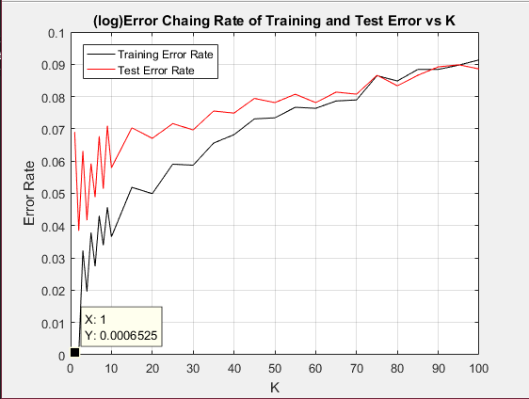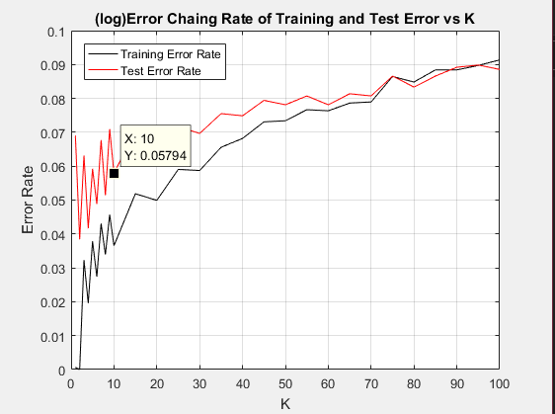 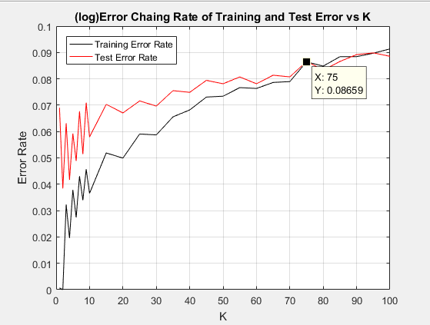

## Training and testing error rates for K = 1, 10, and 100.

|  |  |  |
| --- | --- | --- |
| **K** | **Training Error Rate** | **Testing Error Rate** |
| **1** | 0.000653 | 0.069010 |
| **10** | 0.036542 | 0.057943 |
| **100** | 0.091354 | 0.088542 |

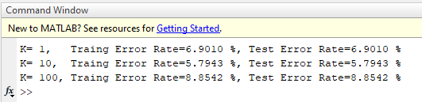

# Q5. Survey

## Time Spent

I am a part-time student, and I have spent 4 working-days on this assignment, spent *16 hours* (around 4 hours per day) in total. Before doing the assignment, I also spent a few days revising the notes since I was not familiar with the formula and terms.

## Feedback

This is my 1st semester in NUS, and I have only taken 2 modules, EE5907 & EE5902, where I can tell the difference between the teaching mode between 2 professors with no doubt. Frankly speaking, Prof. Thomas gave a clear explanation of the topics he covered, and he always encourages his students to ask questions and gave feedback during his class. I enjoyed his way of teaching and believe it could lead me to a better understanding of pattern recognition.